 | IQVIATM Work Instruction Statistical Contribution to a Clinical Study  Report
Document Number and Revision:
CS_WI_BS017 Revision 12
Document Owner:  Carrie Eason | Author(s):  Delphine Millet, Carrie Eason

PURPOSE

To describe the statistical review and contribution to a clinical study report (CSR). Also refer to Refer to Producing a Clinical Study Report (Integrated Clinical / Statistical Report) (CS_WI_MW001).

SCOPE

  - This work instruction (WI) applies to all projects globally where IQVIATM Biostatistics provides review or contributes text to the CSR. Refer to the Stand- alone Statistical Report best practice guidance located in the Biostatistics Training folder in ELVIS for guidance when IQVIA Biostatistics produces a stand-alone Statistical Report.

ROLES AND RESPONSIBILITIES
The following roles perform tasks described within this WI:

Role | Sections
Statistical Team Leader (STL) | 6.1, 6.2. 6.3, 6.4
Senior Biostatistical (SB) Reviewer | 6.3, 6.4
Lead Medical Writer (MW) | 6.1, 6.2, 6.3
Pharmacokinetic Leader (PKL) | 6.1, 6.2, 6.3,
Expert Reviewer | 6.3, 6.4

DEFINITIONS ACCCA:
- Accuracy (free from error or defect; precise)
- Consistency (not self-contradictory; coherent)
- Clarity (easily understood without ambiguity, excess verbiage or redundancy; comprehensible; free from confusion, uncertainty or doubt; effective layout allows for easy understanding [e.g. bullets, indentation])
- Completeness (all parts/elements addressed; lacking nothing; fully detailed)
- Appropriateness (suitable of fitting for a particular purpose)

MATERIAL AND EQUIPMENT
Not Applicable

PROCEDURE

There are two separate procedures detailed in this work instruction. Associated workflow diagrams for this work instruction are provided in Appendix A as follows:
- Workflow no.1: When IQVIA Biostatistics provides review of the CSR provided by Medical Writing.
- Workflow no.2: When IQVIA Biostatistics provides text for inclusion in the CSR.

Steps flagged as (*) are applicable where the IQVIA Clinical Pharmacology (CP) department are contributing to the CSR, as documented in Preparation and Review of CP-Generated Documents (PI_WI_PK0210).

Planning
    - For all contributions to a CSR:

No: | Who: | Step: | When:
6.1.1 | MW | Initiates kick-off meeting. | Prior to authoring
6.1.2 | MW  /STL | During the kick-off meeting, verifies the template and customer specifications used, including publishing requirements (e.g., font size, margin settings, etc.). Refer to Producing a Clinical Study  Report (Integrated Clinical / Statistical Report) (CS_WI_MW001) | Prior to authoring
6.1.3 | STL | May assist the MW in presenting the results during the Data Interpretation meeting, as per Producing a Clinical Study Report (Integrated Clinical / Statistical Report) (CS_WI_MW001). | Prior to authoring
6.1.4 | STL | - Provides the MW with the final Statistical Analysis Plan (SAP), the final statistical outputs plus the Changes to Planned Statistical Analyses Form (CS_FM_BS006) and the Hard Coding Approval Form (CS_FM_BS0243), if applicable.  - Provides guidance to the MW regarding quality tolerance limits (QTL) and other impacts on the project risks, as per Producing a Clinical Study Report (Integrated Clinical / Statistical Report) (CS_WI_MW001). | Prior to authoring
6.1.5 | STL | - If text in the CSR is to be written by the STL: Plans writing of the appropriate CSR section(s).  - If text in the CSR is to be written by the STL: Arranges senior biostatistical review (SBR) of statistical section of the CSR, as per Approaches to QC (CS_WI_BS015).  - Arranges any expert biostatistical review if deemed necessary. Details will be documented in the Biostatistics QC Plan (CS_TP_BS0002). | Prior to authoring
6.1.6 | MW | Arranges a full MW QC review, as per Quality Control (QC) Review of Medical Writing Deliverables (CS_OP_MW005). | Prior to authoring

No: | Who: | Step: | When:
6.1.7 | STL | (*) Collaborates with PKL in compliance with Preparation and Review of CP-generated Documents (PI_WI_PK0210) for studies including Early Clinical Development biostatistics support. | Prior to authoring

Writing
    - For CSR text written by the STL:

No: | Who: | Step: | When:
6.2.1.1 | STL | Refers to any/ all of the following documents:  - Protocol  - Case Report Form.  - Statistical Analysis Plan  - Draft CSR, if available  - Customer-specific report writing template/guidelines, if provided  - ICH Guideline (Topic E3) on Structure and Content of Clinical Study Reports  - ICH Guideline (Topic E9) on Statistical Principles for Clinical Trials  - Statistical Outputs  - Data Handling Report  - Minutes of the Data Review Meeting, or equivalent documentation, if available  - Note to File  - Changes to Planned Statistical Analyses Form (CS_FM_BS006)  - Hard Coding Approval Form (CS_FM_BS0243). | Writing
6.2.1.2 | STL | Follows customer requirements, template, and any specific style guide(s) provided by the MW and/or the customer. | Writing
6.2.1.3 | STL | Verifies that the written text is completely clear and not ambiguous in any way (i.e., complies with the ACCCA definition). | Writing
6.2.1.4 | STL | Applies version control to all versions provided and follows conventions as per General and Trial Master File (TMF) - Specific Document Quality - Good Documentation Practices  (CS_WI_RM0284). | Writing
6.2.1.5 | STL | (*) Prepares the sections of the document describing any statistical analyses or provides sufficient information to the PK scientist to write these sections. | Writing
6.2.1.6 | MW | Edits any text supplied by the STL to make sure that the CSR text is consistent in style, and to aid in the flow of the document. | Writing
6.2.1.7 | STL | Confirms that any changes made to the text by the MW do not impact the statistical interpretation | Writing

    - For CSR text not written by the STL:

No: | Who: | Step: | When:
6.2.2.1 | MW | Writes sections on the planned statistical methods and study results (e.g., using the Protocol and Statistical Analysis Plan as the basis for the planned statistical methods) in consultation with the STL as appropriate, as per Producing a Clinical Study Report (Integrated Clinical / Statistical Report) (CS_WI_MW001). | Writing

Distribution, QC and Review
    - For CSR text written by the STL:

No: | Who: | Step: | When:
6.3.1.1 | STL | Sends the draft document/sections for SBR plus PKL and expert review, as required. | At initiation of the internal review
6.3.1.2 | SB  reviewer | - Verifies that the written text is completely clear and not ambiguous in any way (i.e. complies with the ACCCA definition).  - Performs the review according to Approaches to QC (CS_WI_BS015) and Approaches to QC: Appendix K – QC of the Clinical Study Report or Other Written Report (CS_OD_BS0235), and completes the RFF. Preferably, comments will be annotated as MS Word tracked changes. | During internal review
6.3.1.3 | Expert reviewer | If applicable, performs the review as per the Biostatistics QC plan (CS_TP_BS002) and completes the RFF. Preferably, comments will be annotated as MS Word tracked changes. | During internal review
6.3.1.4 | STL | Addresses reviewer comments associated with statistical sections, as appropriate. | Upon receipt of review comments
6.3.1.5 | STL, SB  reviewer/ Expert reviewer/ PKL | Signs the RFF, indicating that comments were addressed. | Once internal comments are addressed
6.3.1.6 | STL | Provides text to MW for inclusion in the CSR | Once internal comments are addressed
    - For CSR text not written by the STL:

No: | Who: | Step: | When:
6.3.2.1 | STL | Performs review of CSR and sends for expert review, if required | During review
6.3.2.2 | Expert reviewer | If applicable, performs the review as per the Biostatistics QC plan  (CS_TP_BS002) and completes the RFF. Preferably, comments will be annotated as MS Word tracked changes. | During review

6.3.2.3 | STL | Provides consolidated comments to the MW following review, preferably as MS Word tracked changes. | After completion of CSR review
6.3.2.4 | MW  /PKL(*) | Addresses reviewer comments. | Upon receipt of review comments
6.3.2.5 | MW  /Bios staff  /PKL(*) | Signs the RFF, indicating that comments were addressed. | Once comments are addressed
6.3.2.6 | MW  /STL | Signs the Internal Signature Page for Medical Writing Deliverables  (CS_FM_MW007), indicating that comments were addressed. | Once internal comments are addressed
6.3.2.7 | PKL  /STL | (*) Signs the PI_FM_PK0213  Document Review Form indicating that comments were addressed. | Once internal comments are addressed
6.3.2.8 | MW | Sends the draft CSR to the customer. | After addressing all comments from internal review

  - Incorporating Customer Comments

No: | Who: | - Step: | When:
6.4.1 | STL | - Reviews all statistically relevant customer comments received on the draft CSR document.  - Determines if there are any statistical comments that require further discussion with the customer.  - May attend the comments resolution meeting (CRM) set-up by the MW.  - Provides any text/advice required for the MW/PKL to make sure the relevant sections of the document are updated, if applicable  - Must notify the MW of any comments received directly from the customer, or any change to the statistical outputs.  - Arranges for the SB/ expert review of any revised statistical text as described in steps 6.3.1.2 and 6.3.1.3 above, if applicable.  - Provides any amendments or additions to the statistical outputs to the MW/PKL, if applicable.  - Provides explanation of any additional changes in statistical analysis to the MW so that they can be inserted directly into Section 9.8.2 (Changes to Planned Statistical Analyses) of the CSR via a Changes to Planned Statistical Analyses Form (CS_FM_BS006).  - Attends any additional meetings to discuss comments and help resolve any conflicting requests. | After receipt of customer review comments
6.4.2 | STL | Verifies processes/requirements from Draft 1 are incorporated/implemented for Draft 2 and any subsequent version | Draft 2 until final version

6.4.3 | STL | Reviews revised document (or parts) if there are any new statistical presentations, analyses, or changes to the interpretation of study results and/or if requested by the MW/PKL(*) | Draft 2 until final version
6.4.4 | SB  /expert reviewer | Reviews revised document (or parts) if requested by the STL. | Draft 2 until final version
6.4.5 | STL  /SB reviewer/ Expert reviewer | Further review by biostatistics would only be required when significant changes are made to relevant sections of the document. | Draft 2 until final version
6.4.6 | STL | Files the following in TMF in compliance with Trial Master File TMF (CS_OP_TMF0007) and Management and Filing of Biostatistics Documentation (CS_WI_BS0237):  - Reviewer Feedback Form (CS_FM_BS007).  - If IQVIA MW is not contracted:  - Any draft versions of CSR text written by the STL and delivered to the customer.  - Any review comments from the customer relating to CSR text written by the STL, along with responses to the review comments.  - A copy of the final CSR including the signed cover page. | Within 30 days of CSR finalization

- SUPPORTING DOCUMENTATION
DOCUMENT NUMBER | TITLE
ESOP References

DOCUMENT NUMBER | TITLE
7.1 CS_FM_BS006 | Changes to Planned Statistical Analyses Form
7.2 CS_FM_BS007 | Reviewer Feedback Form
7.3 CS_FM_BS0243 | Hard Coding Approval Form
7.4 CS_FM_MW007 | Internal Signature Page for Medical Writing Deliverables
7.5 CS_OD_BS0235 | Approaches to QC: Appendix K – QC of the Clinical Study report or Other Written Report
7.6 CS_OP_MW005 | Quality Control (QC) Review of Medical Writing Deliverables
7.7 CS_OP_TMF0007 | Trial Master File
7.8 CS_TP_BS002 | Biostatistics QC plan
7.9 CS_WI_BS015 | Approaches to QC
7.10 CS_WI_BS0237 | Management and Filing of Biostatistics Documentation
7.11 CS_WI_MW001 | Producing a Clinical Study Report (Integrated Clinical / Statistical Report)
7.12 CS_WI_RM0284 | General and Trial Master File (TMF)-Specific Document General and Trial Master File (TMF)-Specific Document  Quality - Good Documentation Practices
7.13 PI_FM_PK0213 | Document Review Form
7.14 PI_WI_PK0210 | Preparation and Review of CP-generated Documents
External References
7.15 ICH E3 | Structure and Content of Clinical Study Reports
7.16 ICH E9 | Statistical Principles for Clinical Trials
7.17 Best Practice Guidance | Stand-alone statistical report guidelines

- SUPERSEDES
DOCUMENT  NUMBER | TITLE | REVISION NUMBER
8.1 CS_WI_BS017 | Statistical Contribution to a Clinical Study Report | 11

- MODIFICATION FROM PREVIOUS REVISION
CHANGE | SECTION REFERENCE | JUSTIFICATION
Document owner and author updated | Header | To reflect those responsible for the document
Guidance for stand-alone statistical report removed and added in a separate best practice document | Throughout | Guidance for standalone statistical reports is not required in this document
Medical Writer updated to be Lead MW | Throughout | Consistency with MW SOPs
Removed QC step during review of CSR text written by the STL | Throughout | Simplification of process and removal of duplication of effort by QC and SB reviewer
Section reorganized by type of document | 6.0 | To make the sequences of steps easier to identify
Title for PI_WI_PK0210 updated | 6.1.10 | Correction
Reference to the Hard Coding Approval Form added (CS_FM_BS0243) | 6.1.4, 6.2.1.1 | New form
Expert reviewer role added | 3.0, 6.1.8, 6.3.1.1, 6.3.1.2,  6.3.1.5 | Expert review may be required in some circumstances (e.g., specialist statistical knowledge required, SME)
“Analysis Notes” document replaced with “Note to File” document | 6.2.1.1 | For clarity
Added a requirement that when MW are not contracted to write the CSR, the STL must file in the eTMF any draft text written by the STL and delivered to the customer, and any customer comments relating to the text written by the STL plus the | 6.4.6 | Clarification

response to the review comments
Updated reference from Management of Trial Master File (CS_OP_RM0296) to Trial Master File (CS_OP_TMF0007) and  Management and Filing of Biostatistics Documentation (CS_WI_BS0237). | 6.4.6 | Obsolete document, replaced with two new documents.
SB review of CSR text written by MW removed. | Throughout | STL review is sufficient for reviewing CSR text written by IQVIA MW.
Added reference to the Approaches to QC – Appendix K – QC of the Clinical Study Report or Other Written Report (CS_OD_BS0235) | 6.3.1.2 | For clarity
Quintiles replaced with IQVIA | Appendix A | Renaming of company

- APPENDICES

Appendix A: Statistical Contribution to a Clinical Study Report Workflow

Appendix A: Statistical Contribution to a Clinical Study Report Workflow
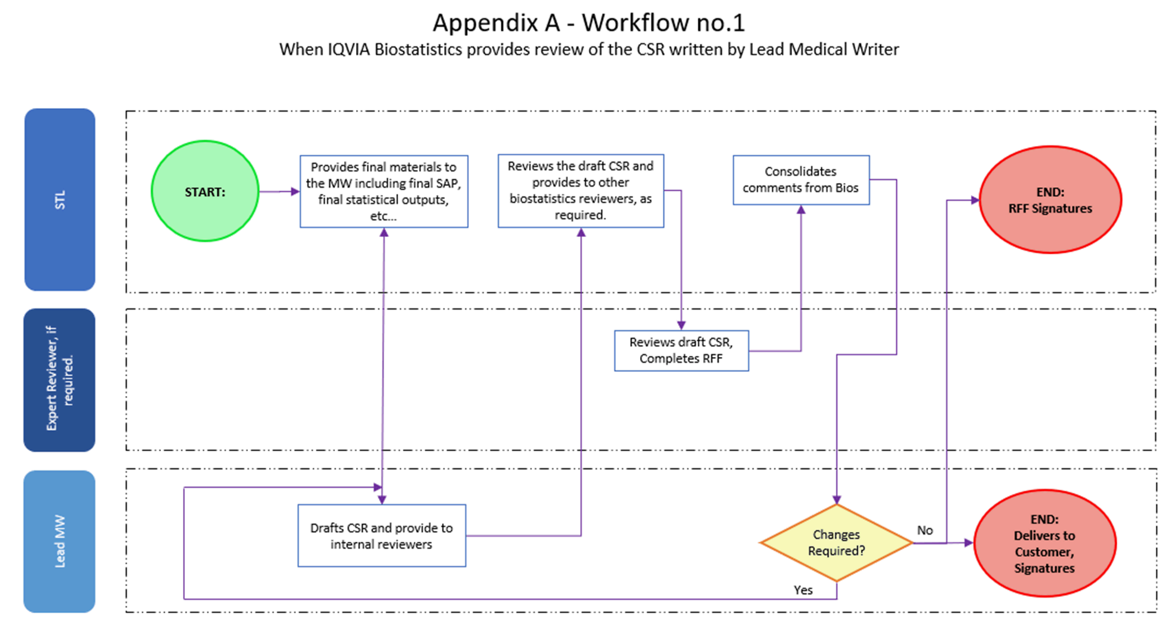

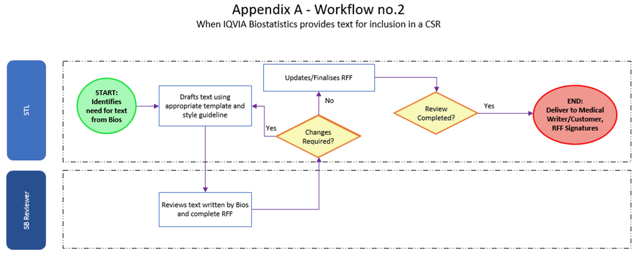

Page 10 of 10
Copyright © 1999, 2000, 2003, 2006, 2008, 2010, 2011, 2015, 2017, 2020, 2022 IQVIA. All rights reserved. The contents of this document are confidential and proprietary to IQVIA Holdings Inc. and its subsidiaries. Unauthorized use, disclosure or reproduction is strictly prohibited.

Standard Operating Procedure Approval Signature(s)
This is a representation of an electronic record that was signed electronically in Content Server.
This page is the manifestation of the electronic signature(s) used in compliance with the organization’s electronic signature policies and procedures
Refer to Signatories CV for Business Title.

UserName: Willmott, Corinne (q778849) Title:
Date: Tuesday, 15 November 2022, 10:38 AM Eastern Daylight Time Meaning: Signing this Document Indicates My Approval
================================================

UserName: Bickford, Emma (q637065) Title:
Date: Tuesday, 15 November 2022, 01:51 PM Eastern Daylight Time Meaning: Signing this Document Indicates My Approval
================================================

